Git repository- https://github.com/vishalanerao/Capstone_Project_SDET_Basic_3.git

Case Study using POSTMAN API Automation

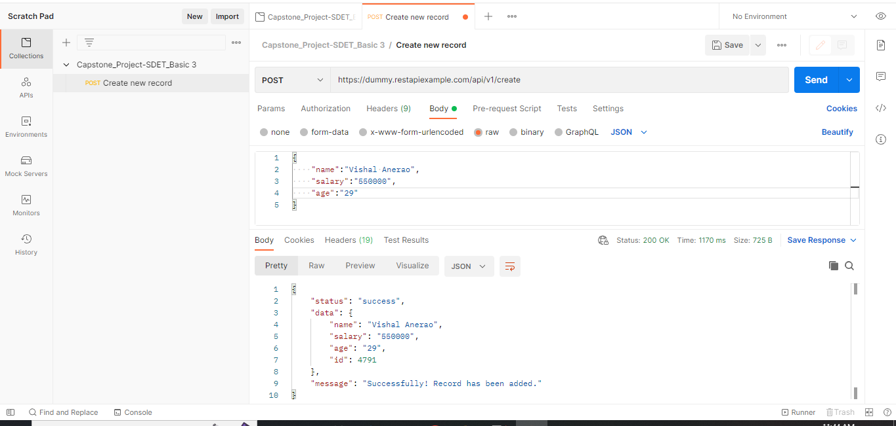

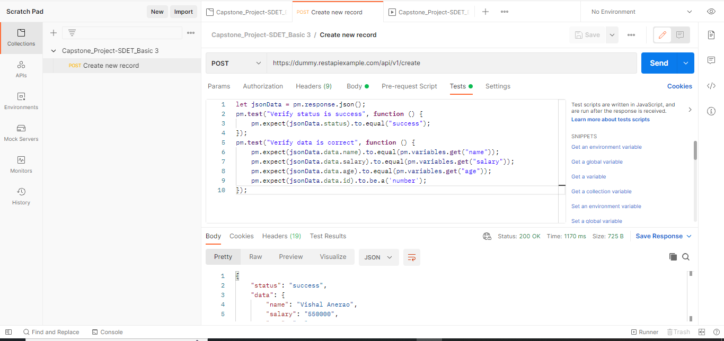

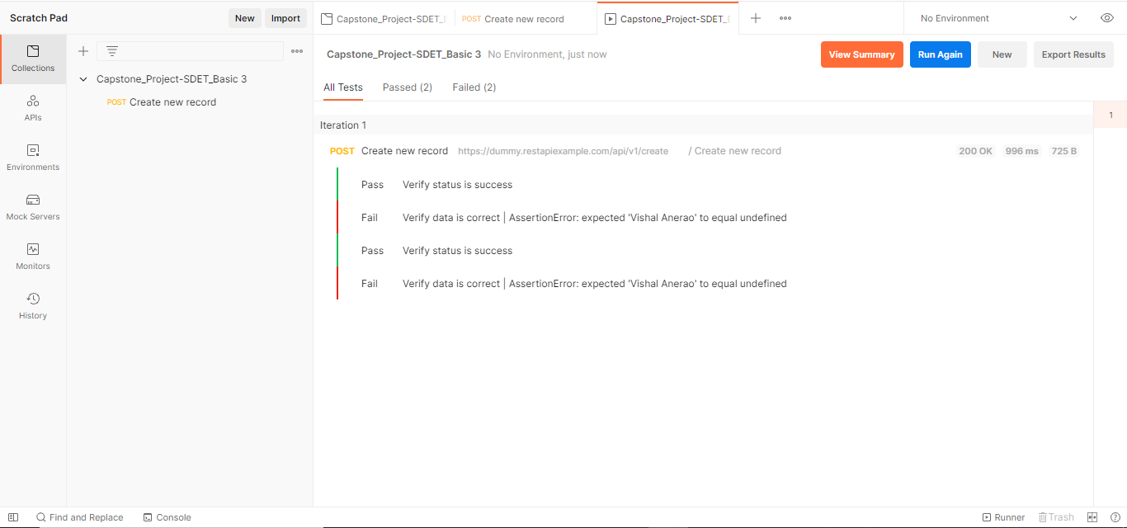

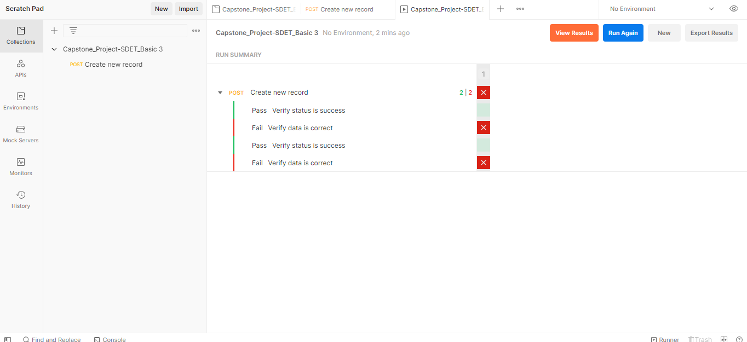

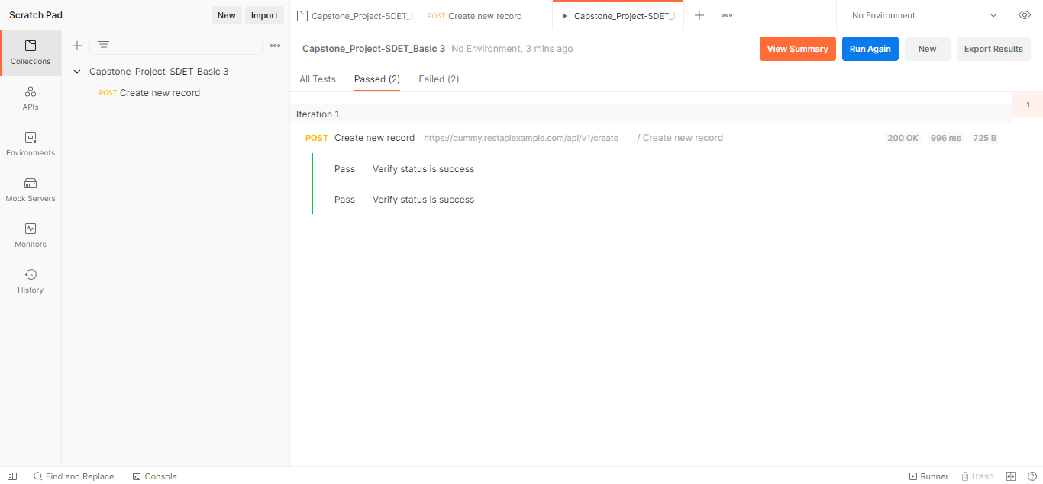

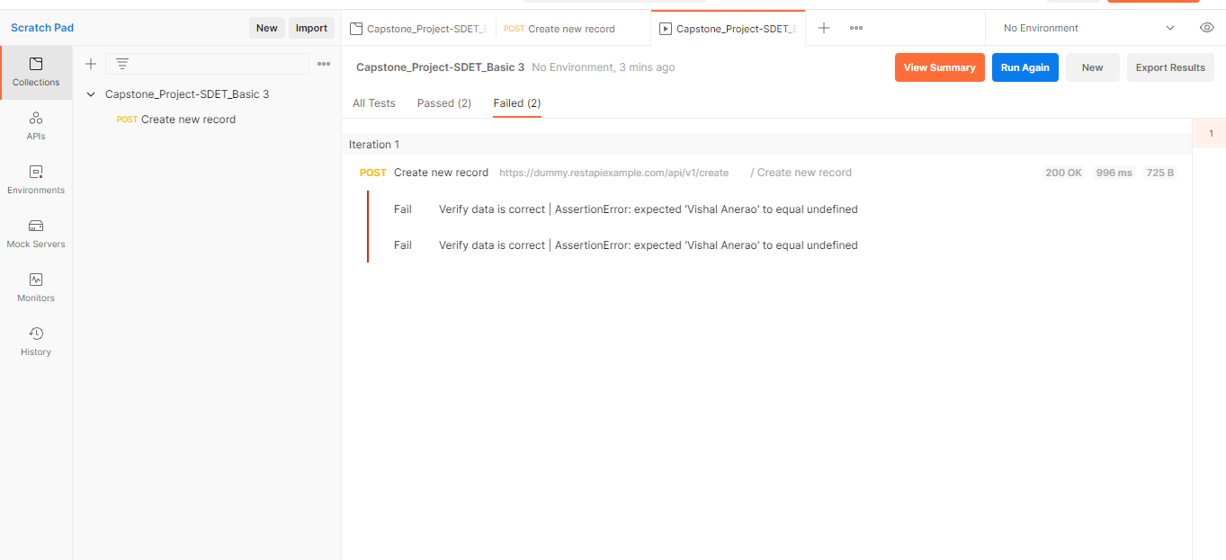

Case study project using Selenium with Java concepts

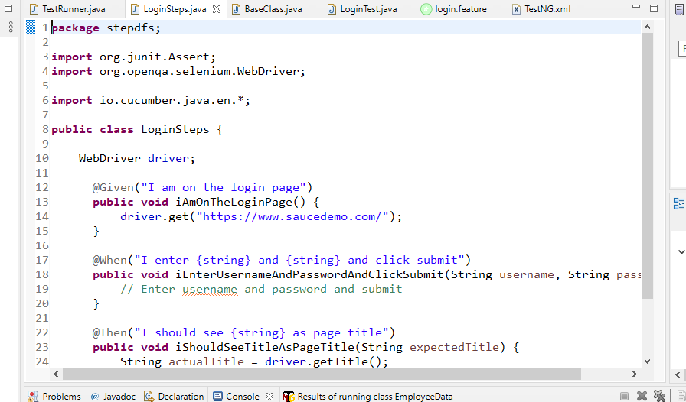

capstone project using Selenium with Python concepts

# conftest.py

import pytest

from selenium import webdriver

@pytest.fixture(scope="module")

def browser():

driver = webdriver.Chrome()

yield driver

driver.quit()

# test_login.py

import pytest

@pytest.mark.parametrize("username, password, title", [("gooduser", "goodpass", "Swag Labs"), ("baduser", "badpass", "Epic sadface: Sorry, that username and password do not match any user in this service")])

def test_login(browser, username, password, title):

browser.get("https://www.saucedemo.com/")

# Enter username and password and click submit

# Verify title or error message

---------------------

# test_login.py

import pytest

from selenium import webdriver

from openpyxl import load_workbook

@pytest.fixture(scope="module")

def browser():

driver = webdriver.Chrome()

yield driver

driver.quit()

def read_data_from_excel(file_path):

# Read data from Excel using openpyxl

pass

def test_successful_login(browser):

# Test successful login functionality

passs

def test_unsuccessful_login(browser):

# Test unsuccessful login functionality

pass